Pelvic Floor Therapy: Urinary Incontinence & Pelvic Organ Prolapse PAGE 1
PAGE 2
- Urinary incontinence is defined as any involuntary leakage of urine. There are 3 main types of urinary incontinence; urge, stress and mixed.
  - Urge incontinence is characterized by leakage following a sudden need to urinate for example, hearing rushing water and putting your key in the door.
  - Stress incontinence is described as urinary leakage that happens in circumstances of physical exertions such as sneezing, coughing, jumping and running.
  - Mixed urinary incontinence is a presentation that includes symptoms of both stress and urge incontinence.
  - Approximately 25% of young women, 44-57% of middle-age woman and 75% of older woman experience some involuntary urine loss. Urinary incontinence affects quality of life and has a large economic and societal impact.
- Pelvic Organ Prolapse is the descend of one or more aspects of the vagina and uterus and occurs when organs are herniating in to the vaginal space.
  - Prolapse includes bladder, uterus and rectum through the posterior vaginal wall.
  - Symptoms of a prolapse include sensation of a bulge, stress incontinence, necessity for bowel splinting, incomplete bladder or bowel evacuation, back pain, and sexual dysfunction.
  - Risk factors include number of vaginal deliveries, age, family history, obesity, connective tissue disorders, chronic cough conditions, chronic constipation, weight lifting and menopausal state.
  - The international prevalence of this condition among women of childbearing age and older is estimated between 32% and 64%.
PAGE 3 – BIO AND CLINIC
Page 4
  - Biofeedback – Add biofeedback image from below based on clinic
    - Biofeedback. Biofeedback training includes external or internal sensors which are placed on the pelvic floor musculature which record the muscle activation output on to a monitor which the patient will visualize during activity for live recording of what the muscles are doing. Research has shown pelvic floor strengthening with use of biofeedback has greater strength improvements than without.
  - Phase 1
    - Kegel- Pull your pelvic floor tissues up and in, similar to stopping your urine mid-stream or not allowing gas to pass. You should feel the perineal tissue elevate and the activation should be felt deep under your belly button. Slowly activate as you gently exhale.
    - Bridge: Just Picture
    - Clam: Just Picture
    - Transverse Abdominis Bracing: Just Picture
PAGE 5
  - Phase 2
    - Kegel endurance holds: Progression to breathing normal with pelvic floor activation beginning with 10 seconds and progressing up to 60 seconds. This is used when training for pelvic organ prolapse.
    - Sit to stand- Just picture
    - Squat- Just picture
    - Step up- Just picture
  - Phase 3
    - Kegels:
      - Quick Flicks: 3-5 quick pelvic floor contraction with maximum relaxation achieved between repetitions. This is used for urge incontinence.
      - Percentage holds: Activating the pelvic floor muscles with 50% of max, 25% of max and 10% of max in order to work on endurance and high level activities including running and fitness classes.
    - Balloon Blowing: Perform a maximal pelvic floor contraction prior to blowing a full breath of air in to a balloon in order to simulate the pressure created with coughing and sneezing.
    - Bosu – Just picture
    - Rocker Board- Just picture
    - Running Mechanics- Just picture
PAGE 6/7
- Bladder Diary- Pelvic SIG Journal in Marketing Store (Just first 2 pages)
PAGE 8
- FAQs
  - What will my first evaluation look like?
    - The first examination visit is around 1 hour in length. It comprises of a general orthopedic lumbo-pelvic screen including hip, pelvic and lumbar mobility, strength assessment and special tests. Followed by an internal vaginal pelvic floor exam with digital palpation to assess for the ability to perform a Kegel, relax, bear down to identify pelvic organ prolapse and tissue palpation for pain and scars. No stirrups or speculum is utilized.
  - How long will this take to resolve?
    - We generally see resolution between 8-12 visits based on the chronicity and severity of your case. If we do not see improvements but then we will refer you to the correct medical care provider for further interventions
  - How are Kegels done different for stress vs urge vs prolapse treatment?
    - Exhale and Kegel coordination is used for stress incontinence as coughing, sneezing and physical activity all occur with a forceful exhale. Quick flick activation of the pelvic floor is utilized for urge suppression with the reflex arc of reciprocal inhibition to the over active bladder muscle. Endurance and partial activation Kegel holds are taught to overcome symptoms of pelvic organ prolapse.
  - Do physical therapists have extra training to treat pelvic floor?
    - Yes. Every therapist treating pelvic floor must have taken extra coursework beyond physical therapy school with a lab portion in order to work on the pelvic floor region. Therapists training varies from a weekend course, PRPC through Herman and Wallace and WCS through the APTA.
  - Does PT resolve incontinence and prolapse?
    - Yes, based on the chronicity and severity of the symptoms. If you put in the work; attend appointments as recommended by your PT in regards to frequency and duration and complete your home exercises as prescribed you can eliminate urinary incontinence and resolve symptoms of pelvic organ prolapse.
  - What else besides Kegels will my PT have me doing?
    - Bladder retraining by understanding current bladder habits including voiding frequency, duration, aggravating factors for leakage, water and food intake.
    - Exercises to emphasize hip, abdominal and pelvic floor activation
    - Biofeedback
    - Diaphragmatic Breathing
  - Is peeing your pants normal after having kids?
    - No. Peeing your pants is never normal, but it is common. You can laugh, sneeze, cough and run without urine leakage after having children.
Page 9 – Diagrams Below- Urge Suppression Education:
Page 10- Functional Assessment:
Functional Assessment Questions: All answers “Not at all” “Somewhat” “Moderately” “Quite a bit”
- Do you have urine leakage with coughing, laughing, jumping or running?
- Do you have urine leakage associated with urgency such as running water or putting your key in the door?
- Do you experience a strong sense of urgency and have to rush to the bathroom to urinate?
- Do you feel a bulge or heaviness in your vagina?
- Do you have to press your finger along your perineum and vaginal floor to fully evacuate bowels?
- Do you usually experience a feeling of incomplete bladder emptying?
- Do you feel you have not completely emptied your bowels at the end of a bowel movement?
Page 10- Back page with Pelvic Podcast Info
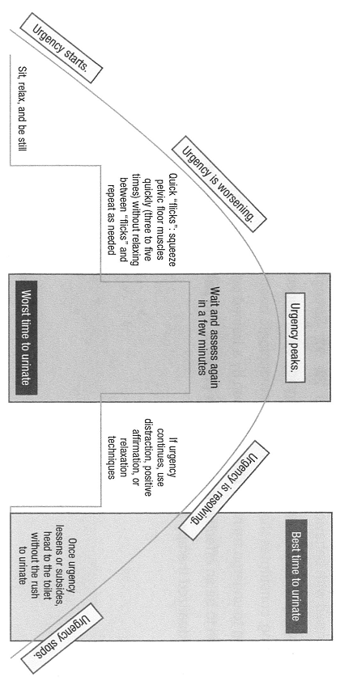

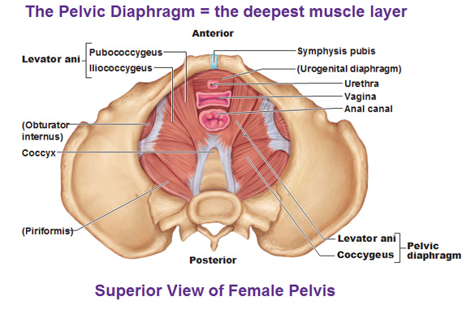

Bridge
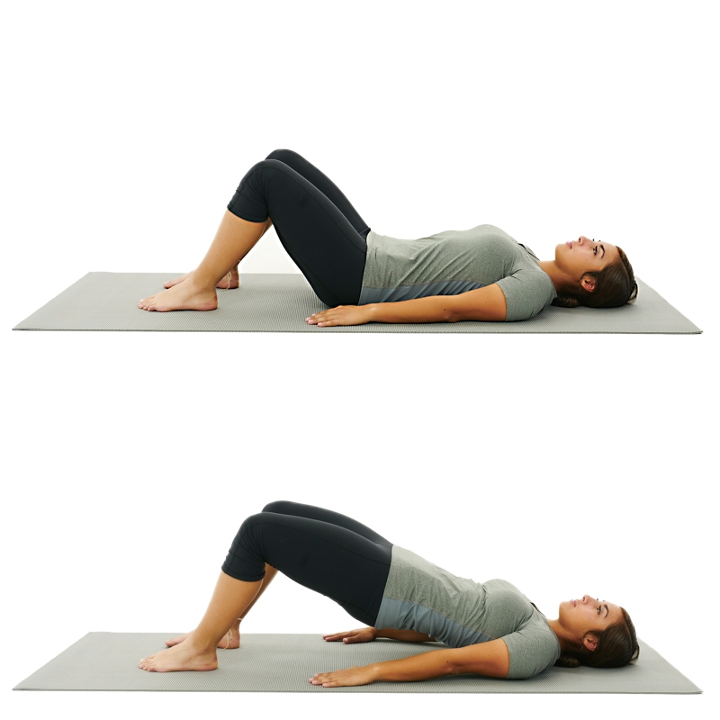
Clam
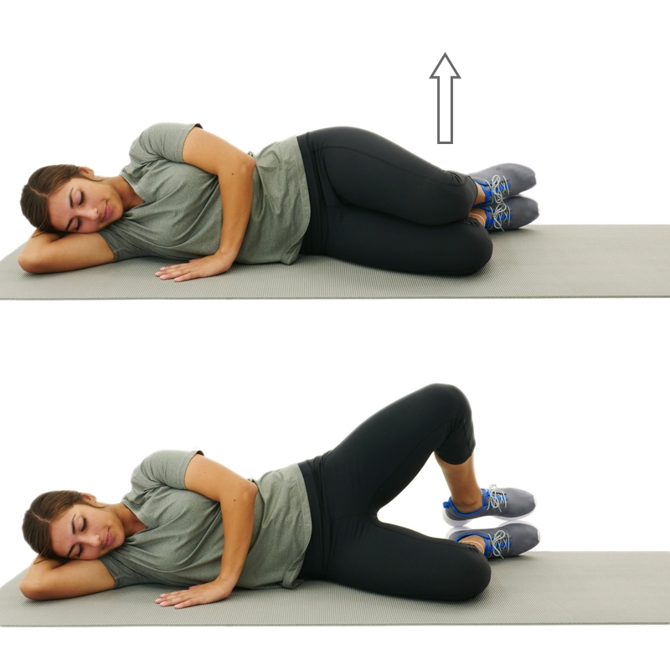
Bird Dog – INSTEAD OF Transverse abdominis
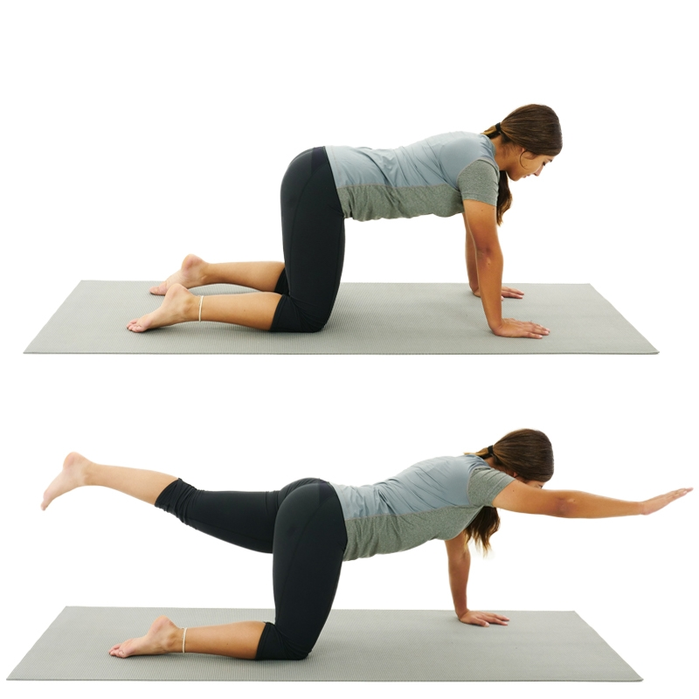
Sit to Stand
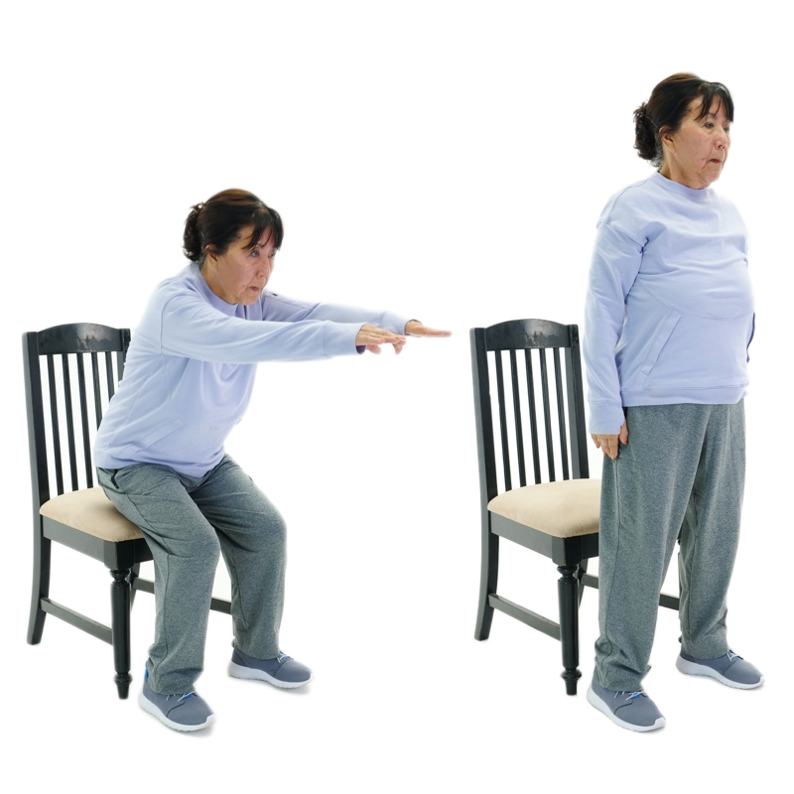
Squat
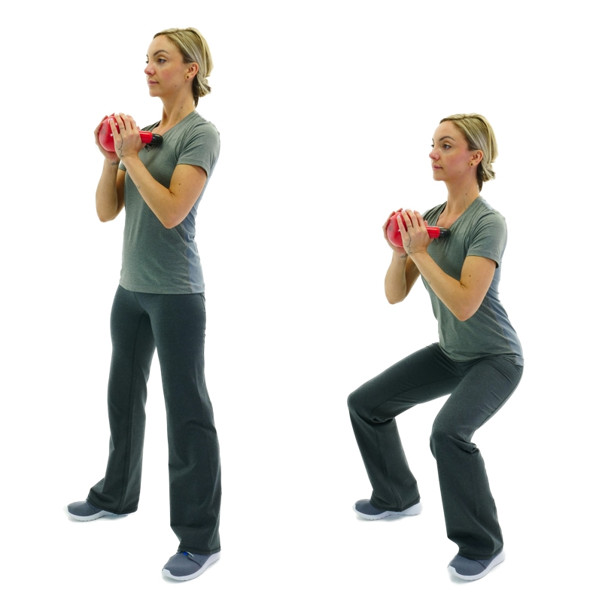
Step up
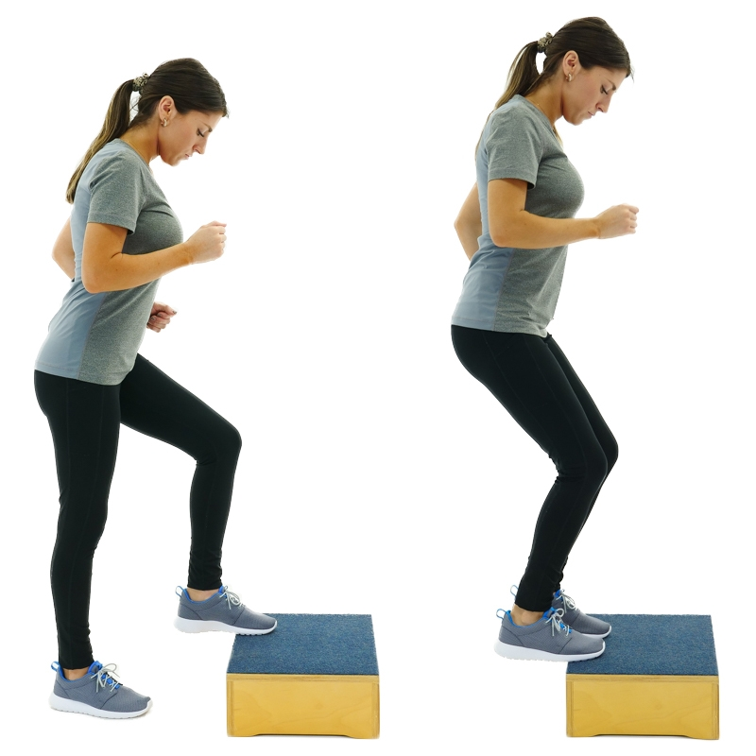
Squat Jump
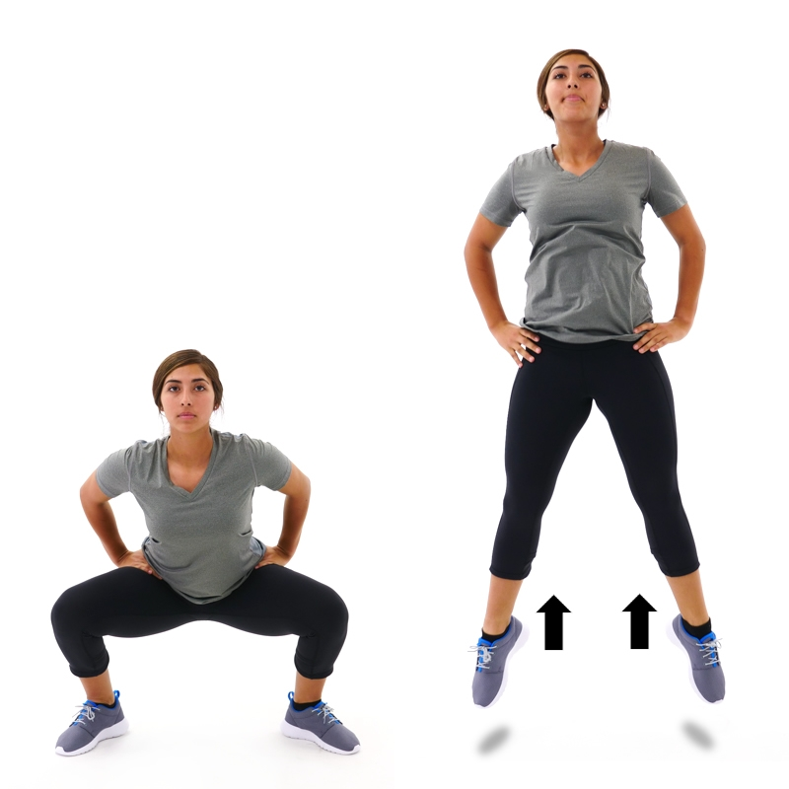
Bosu
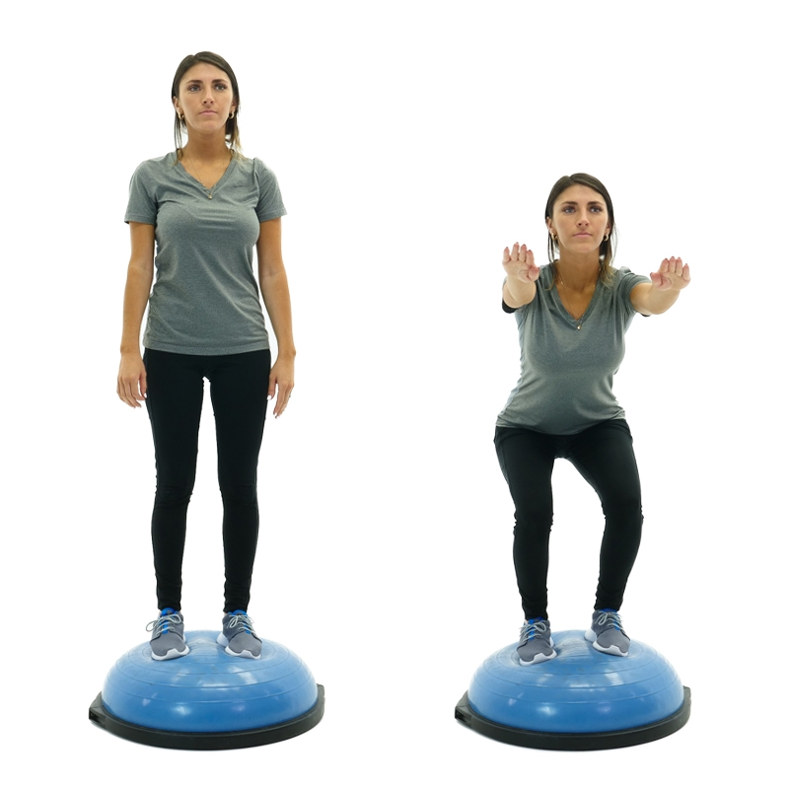
Running Mechanics
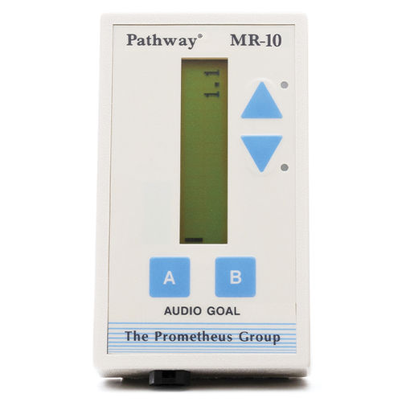
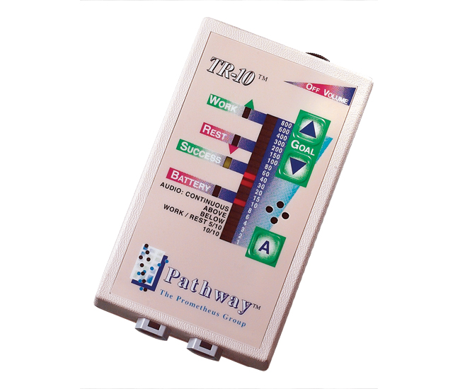
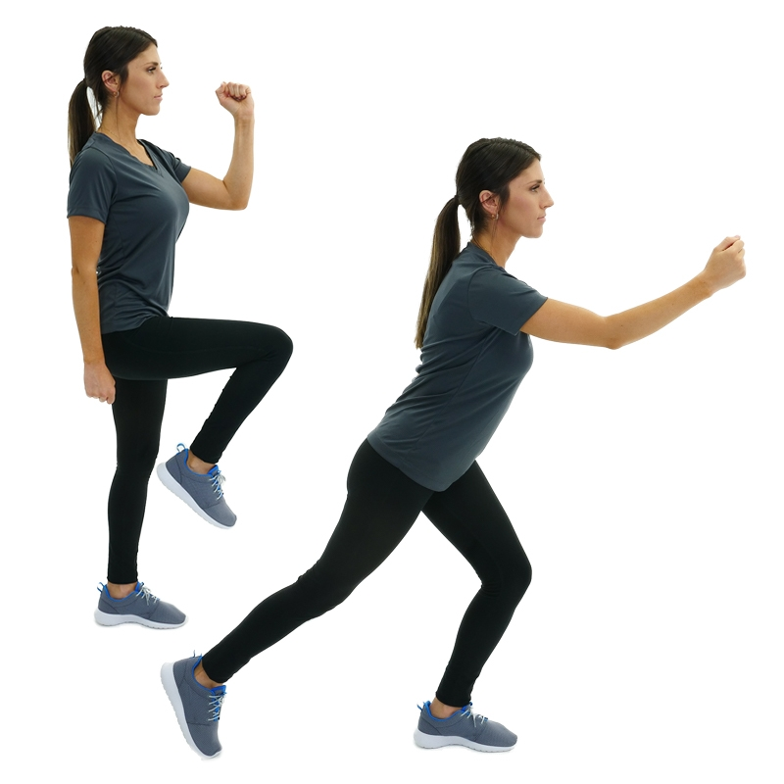Biofeedback Images: US TR-10 for Merenci in Santaquin

